OVERVIEW

This viewer supports the Egosoft space-sim games X2, X3:Reunion and X3:Terran Conflict.
It also supports modifications of any of the above.
Data comes directly from the game files, and is read-in each time the Viewer is run.

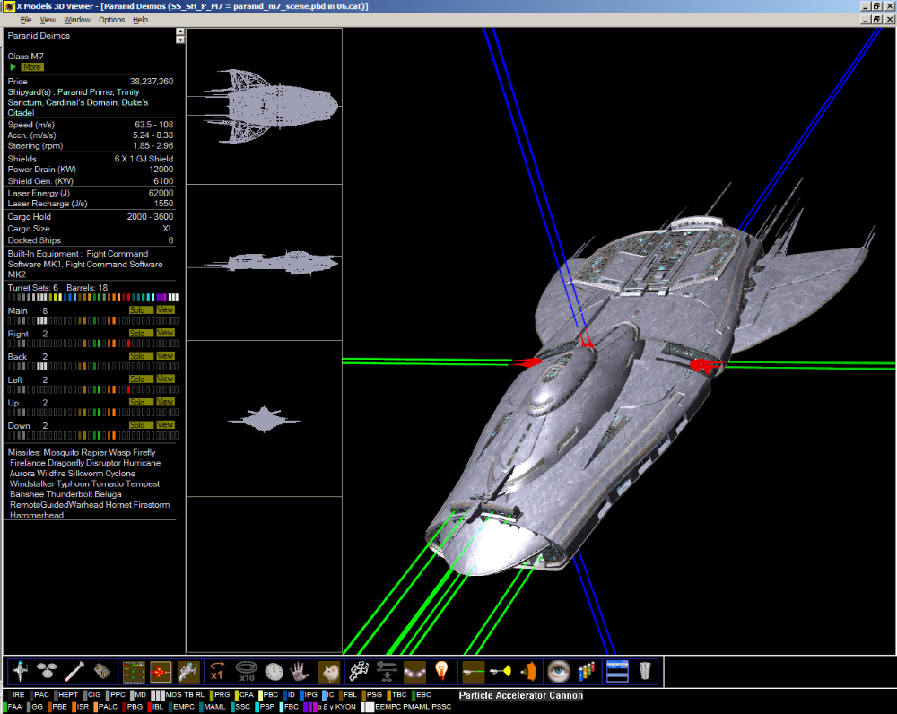

There are three main windows per loaded ship (you can load as many at once as you think your PC can handle):

1 Ship statistics and available weapons (left)
2 Two-D ship siloette drawing (middle)
3 Three-D ship animation (right)

The 3D window will animate the ship in such a way as to view (eventually) all parts of the ship,
You can control the ship rotation with the mouse after clicking the WhiteMouse button
(more details further down).

You can move the 3D ship closer or further away by using the mouse wheel.

The status-bar at the bottom shows all weapons, move the mouse over any one to see the full description, and show which ship guns fire this weapon (in above screen-shot the mouse is over the particle accelerator cannon & the down, up and back gun turrets are showing their nominal firing direction as a blue beams).

You can run multiple instances of the program, which can be useful if you’ve got a dual screen set-up.

Running the Viewer for the first time

You will need to tell the Viewer which X-game directory to use e.g. :

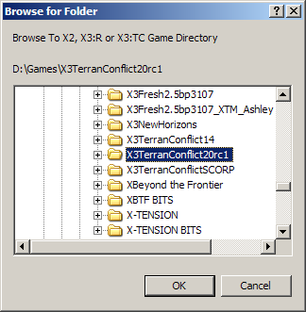

Running the Viewer

Every time the Viewer is loaded , it will scan the game files, this doesn’t take long, a progress dialog is shown :

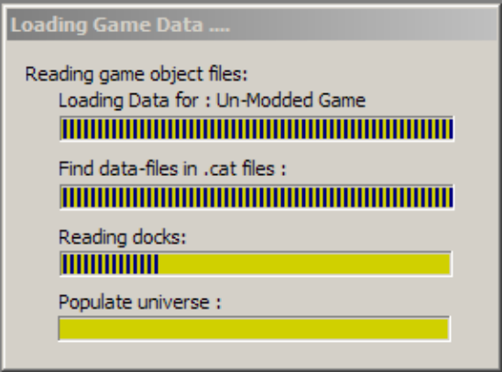

During the above process, a file is generated called CatFiles.txt (saved to the chosen X-Game directory),
this contains the names of (the most recent version of) each file that was encountered (this is just for info).

When you load model(s), a further progress dialog is shown, large models take longer than smaller ones,
this doesn’t take long either:

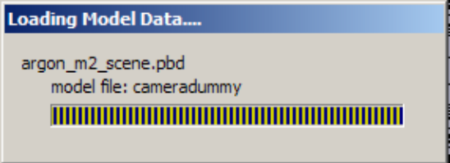

MENUS

FILE
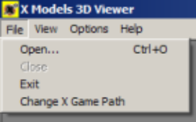

Open
Same as the toolbar 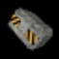 button, see below for details.

Change X Game Path
You can change to a different X-Game installation at any time,
the chosen game path will be remembered for the next run of the Viewer.

VIEW
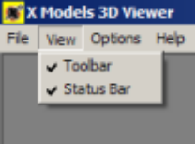

Toolbar ; means the main controlling toolbar (see details below details),
this bar can be undocked by dragging in the far left of the bar.
Status Bar means the weapon-bar at the bottom of the main window.

OPTIONS
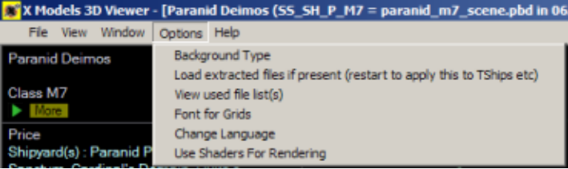

Background Type

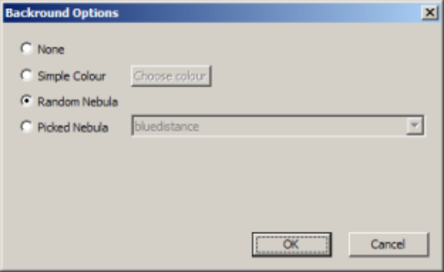

None : gives just a black background.
Simple Colour : allows a choice of colours, the ‘Choose Colour’ button shows a colour selector.
The actual colour you get will be significantly brighter than the chosen one, for rendering reasons.
Random Nebula : loads a random game nebula for each new loaded window.
Picked Nebula : allows you to choose a game nebula for all new windows.

Load extracted files if present
See further down for details of this.
View used file list(s)
This is the same as the toolbar button , see below.

Grid Font
You can choose the font for any grid (load ship, station or missile) .

Change Language
The data language is controlled by the lang.dat game-file, but you can change this on-the fly.
The choice of languages presented depends on the presence of certain game files e.g.:

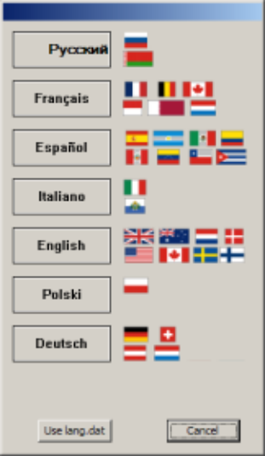

Use Shaders For Rendering
Makes use of the Egosoft shaders, but the lighting is a bit poor at the time of writing (this is in development).

HELP
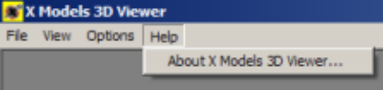

Shows an ‘about’ window, with links to Egosoft’s forum,
and a link to the forum post which can be checked for Viewer version updates.

Scrolling the Stats Data

The spin button control  in each of the stats windows allows you to scroll them all together,
this is useful if you have several ships loaded, and some of the stats are off the bottom of the window.
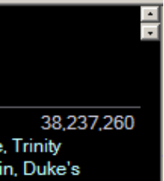

Descriptions and Audio

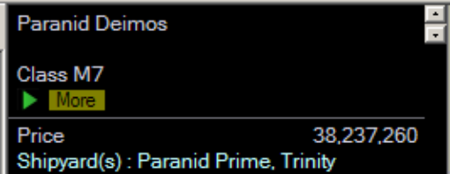

The green arrow button will play the audio for the race + name of the ship / station / missile.

The ‘More’ button will open the below window, showing descriptive text, this can also be played as audio.

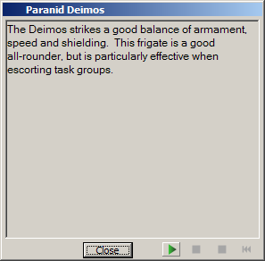

Toolbar at bottom of screen

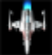
Open ship(s) Open factories Open missiles Open model / scene file(s)
(extracted with ModManager)

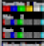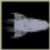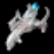
Show/hide statistics Show/hide 2D line drawing view Show/hide 3D animation view

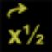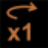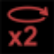
Animation speed Internal movement 10 times normal


Reset animation time Freeze animation Toggle mouse-control
of animation rotation

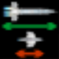
Wire-frame mode Show models to scale


Show/hide ‘model lights’ Lighting settings
(normal, brighter, just diffuse)

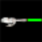
Show/hide highlighting of weapon Show/hide highlighting of weapon Show/hide cockpits
BEAMS or factory nodes CONES or factory nodes


View list of component files HQ spray-shop simulation

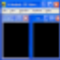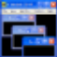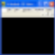
Tile windows horizontal, tile vertical, Close all open windows
cascade or maximise windows

Open ship(s)

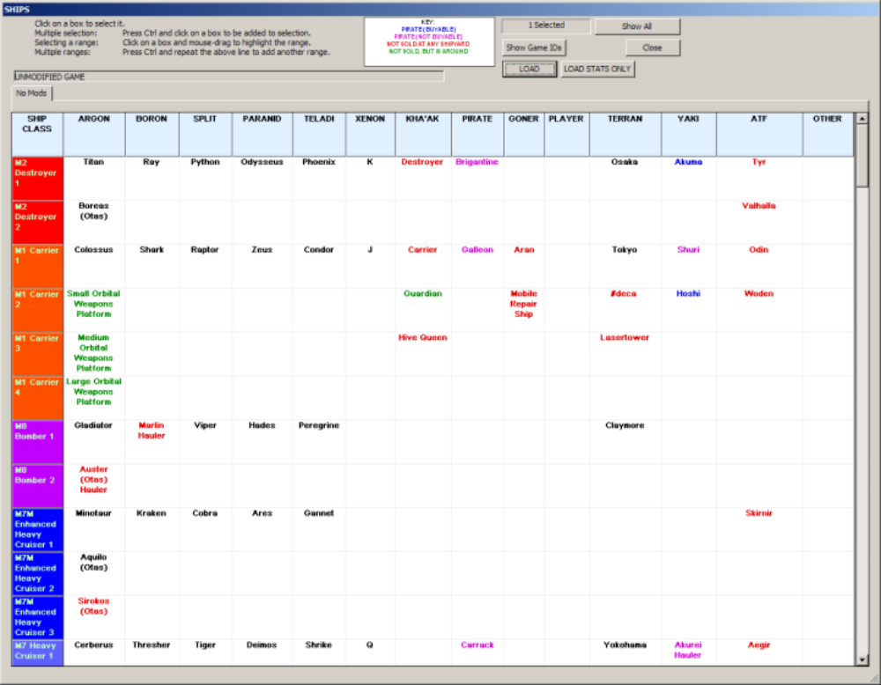

The tabs at the top allow selection of the ‘dataset’, i.e. you can view either the standard (vanilla) set, or
one of any MOD packages you may have installed.
You can load models to from different datasets at the same time, by selecting models in one tab,
then changing the tab and selecting further models.

If you ‘Load Stats Only’ instead of ‘Load’ then the model is not loaded (much quicker if you’re only
interested in seeing the stats + you can get a lot more loaded at the same time).

The ‘Show All / Show Normal Set” button turns on & off ‘extra’ ships,
e.g. ships that are not in the game (perhaps game development left-overs).
This button is ‘sticky’ in that the setting stays as you last had it even when you re-run the program.

The ‘Show Game IDs’ button turns on & off the internal game-ID (e.g. SS_SH_A_M6 for Argon Centaur).

Open Factories

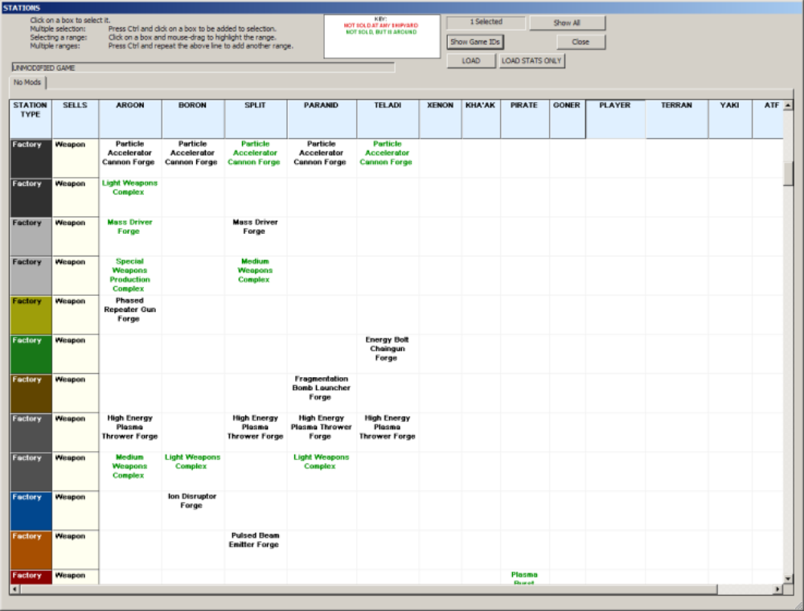

Factories and Docks are shown grouped by type, many factories use the same model.

You may have to scroll down to get to the factory you want to load.

For MOD-datasets, new factories may not have the production stats, since the details may be scripted-in
during at game load-time, rather than being available in the game data files.

The stats for factories are completely different than those for ships, as shown below

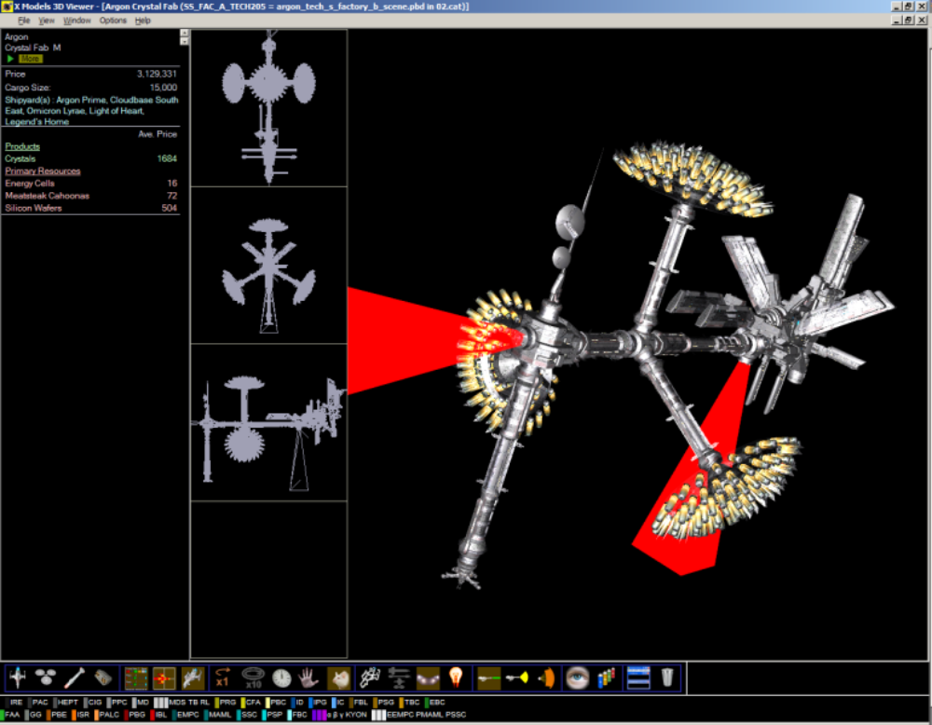

The red bars coming from the factory indicate the connection node positions/directions (for making factory complexes).
These are normally not shown & are toggled on/off with the or toolbar icon
(i.e. same buttons as for weapons, see below).

Previous versions of the Viewer show extra information, e.g. profit, stock etc, this is not present here (yet).

Open Missiles

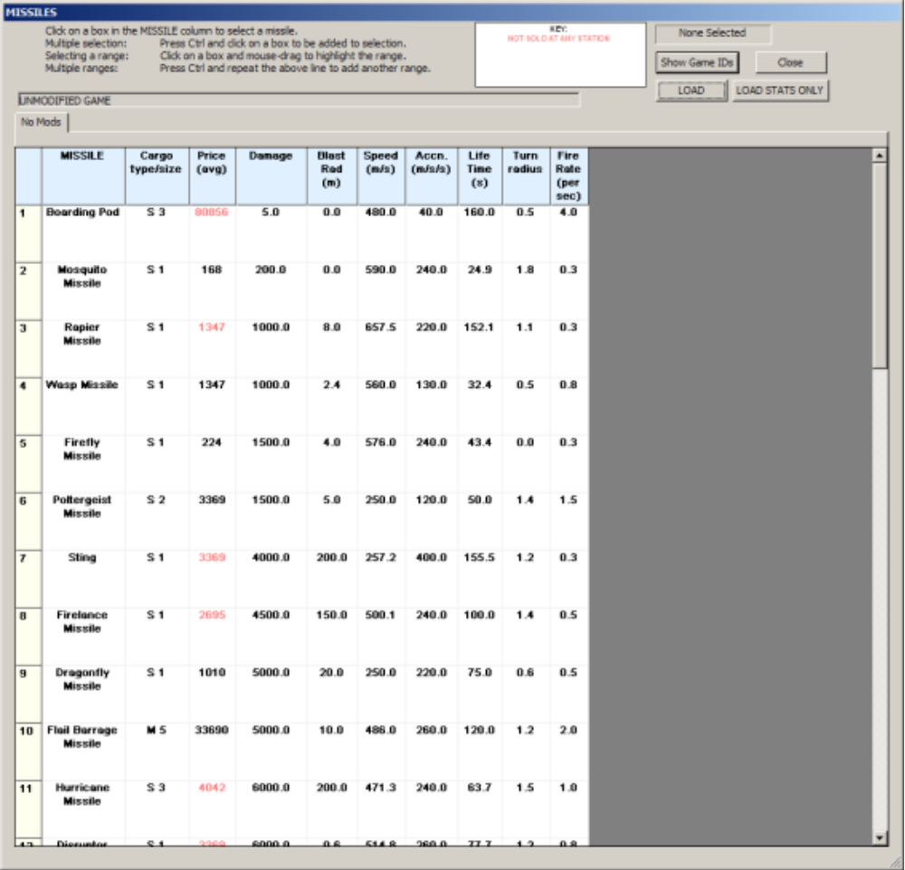

This is a much simpler layout, you can select items from the ‘MISSILE’ column, other columns are just data.
When you ‘LOAD’ a missile you get to see the same numbers, and also the individual missile model.

Shield data is not a feature yet, this may be added in a later version along with other ware data.
There are no shield or ware 3D models in the game in any case.

Open model / scene file(s)

This will show a standad file-open dialog, which enables loading of files extracted with doubleshadows
ModManager utility program.
http://forum2.egosoft.com/viewtopic.php?t=103977

The loaded data is divorced from any other game-file data, ie stats data will not be show.
Many scenes & models are not ships, factories or missiles, but with this button you can at least browse them.

Show / hide statistics window

Show / hide 2D line drawing window

Show / hide 3D animation window

Animation speed

This button controls the 3-D animation window rotation speed

Internal movement 10 times normal

If a model has internally moving parts (e.g. antennaes on large ships, rotating trading stations),
this button can be pressed to speed up the internal movement.

Reset animation time

This will reset the 3-D model’s rotation to a given position, also the light rotation is reset.

Freeze animation

This button halts the 3-D animation

Toggle mouse-control of animation rotation

When you click this button, automatic 3D animation stops and you can control the rotation of the ship by moving the mouse over the ship, then holding down the left mouse button and moving the mouse around.

If you hold down the right mouse button, then all models will rotate together.

As said above, you can also move the ship closer / further using the mouse wheel,
holding down the right mouse button while rotating the mouse wheel will move all models together.

If animation is frozen, then mouse still changes the ship rotation.

Wire-frame mode

Wire frame mode enables you to see ‘through’ the ship body (it’s easier to see all highlighted guns)

Show models to scale

Showing ships to-scale will keep the biggest ship the same, and reduce the size of the others
to the correct relative scale (you might only get a dot in the middle if you’ve got a small ship and
a very large ship).
The window showing the largest model has a ** at the beginning of the title,
all other models sizes are now locked relative to this window.
You can use the mouse wheel, when this window is selected (i.e. has a blue title bar),
to move all models closer or further.

In this mode, you temporarily lose any ship movement made with the mouse wheel when any other window is selected, this is re-instated when you exit this mode.

Show/hide ‘model lights’

Turns on/off the cabin lights & headlights, this is not exactly an accurate statement,
but the effect is something like it.

Lighting settings

(normal, brighter, just diffuse)

Lighting similar to that ‘in-space’, the ship rotates and so does the light direction, so you get
to see all parts of the ship with all directions of lighting (if you wait long enough).

Brighter and more diffuse lighting, giving less detail, but easier to see more of the ship at once.

No directional light, just fully diffuse lighting, looks very ‘flat’, but you see all of the ship.

Show/hide highlighting of weapon BEAMS or factory nodes

If a ship has any weapons, they will be highlighted red, and a green ‘laser-beam’ comes out of each weapon
to show the nominal direction of firing.

If you move the mouse over ‘Solo’ button (if present) in the statistics window (by each gun-turret front, left, up
etc) then the (originally green) beams from each gun in this turret will flash blue.

Also stations will show the factory node position(s) with a red elongated box.
Show/hide highlighting of weapon CONES or factory nodes

Since any ship gun can fire in various directions, the beam indicator above is just that, an indicator.
The actual ‘firing-cone’ for each weapon varies with the weapon type and location on a ship.
Any gun can only fire towards direction that can be seen from the cockpit (main front guns are more limited),
this button show/hides the firing-cones as transparent yellow curved surfaces e.g. :
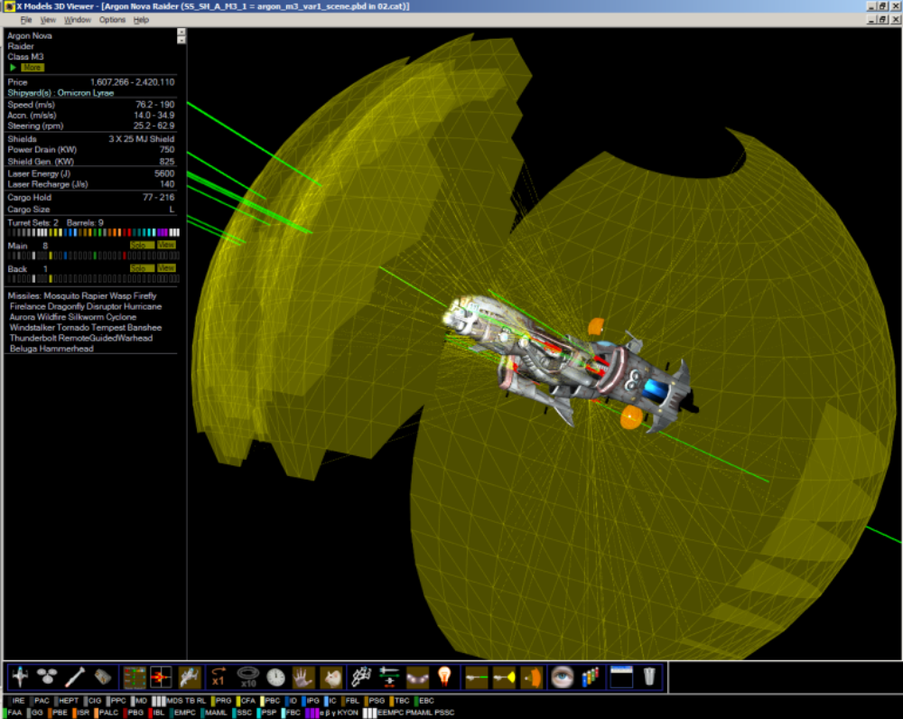

Show/hide cockpits

The orange shapes in the above image show the position and angular spread of each cockpit.
There is a small white sphere at the actual cockpit position.

For both the and buttons there are extra buttons in the statistic window that can be used to select
and/or view the gun turrets.

e.g. ‘Solo’ buttons:
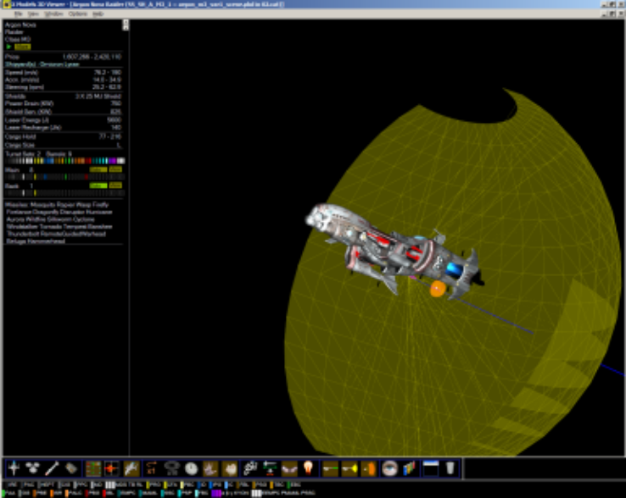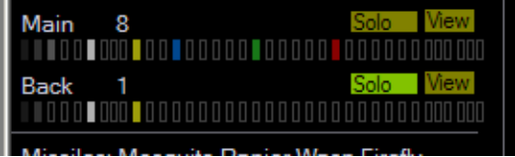

and e.g. ‘View’ button
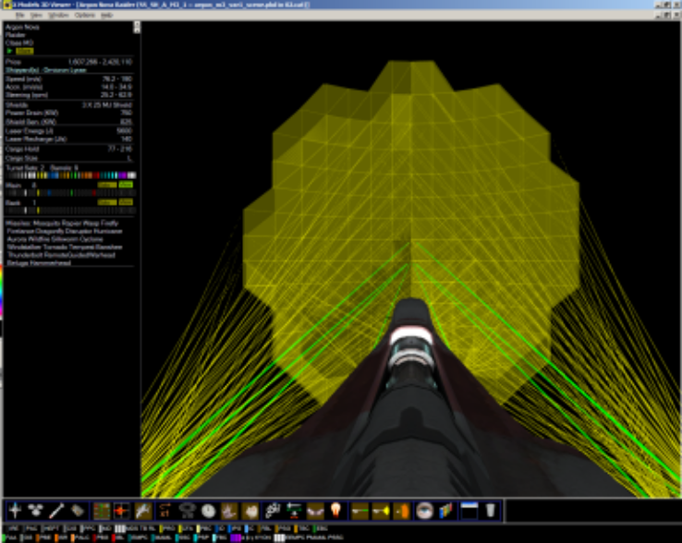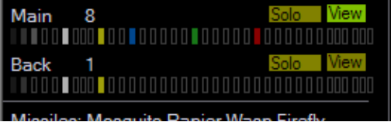

Show List of component scene / model / texture files

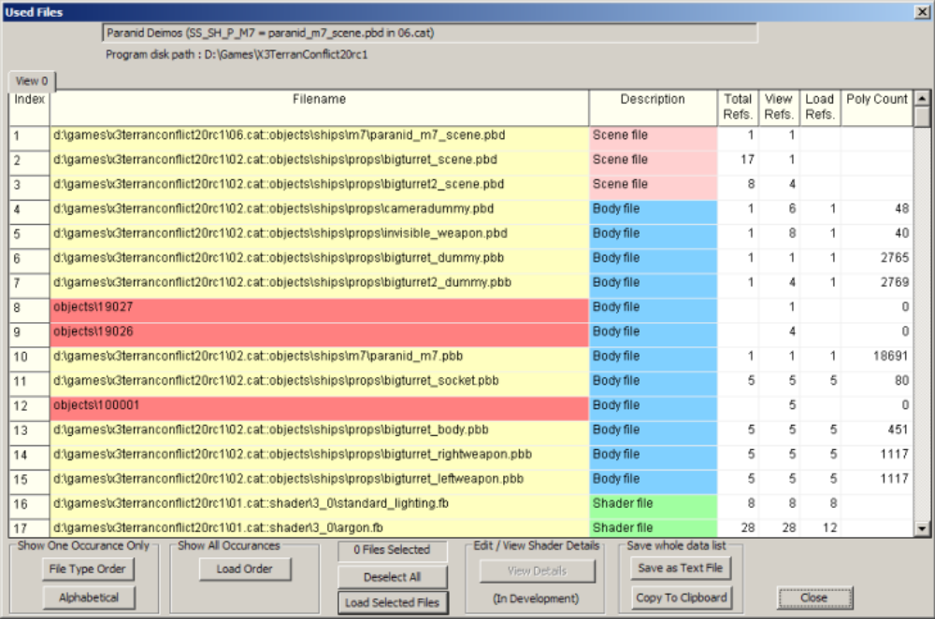

This window shows all files that go to make up the indicated scene/model.
The initial state is ‘One occurance, File-type order’.
The red colour indicates a file that was not loaded (could not be found), these mostly indicate a special object that is used in ‘creating’ eg a station docking arm or ship docking bay (ie the viewer does not currently supported these objects, possibly these will be in a later version)

You can select file(s) in the ‘Filename’ column (selected rows will turn blue),
and then click ‘Load Selected Files’ to load them:
Scene files : these will be loaded into the running program,
Texture files : these will open in whatever application you have associated with the filetype (jpg, tga, bmp)
e.g. PaintShopPro.
(for .dds format texture files, you will need a viewer program (eg Microsoft’s Direct-X utility DxTex.exe)).

You can save the currently showing list as a text file, or copy to clipboard (& e.g. paste to Excel).

If you are not ‘loading from extracted files’ (see below) which is normal, then a texture file will load as above,
but a temporary file is created in your ‘temp’ directory (eg C:\Documents and Settings\<user>\Local Settings\Temp), so if you do this a lot you might want to clear the temporary files out occasionally.
If you are ‘loading from extracted files’ then the extracted texture file is loaded directly to the associated program.

The ‘Body Shader Params’ button will open up the details of shader usage, this is in development,
but shows the correct info AFAIK.

This is really a modding facility
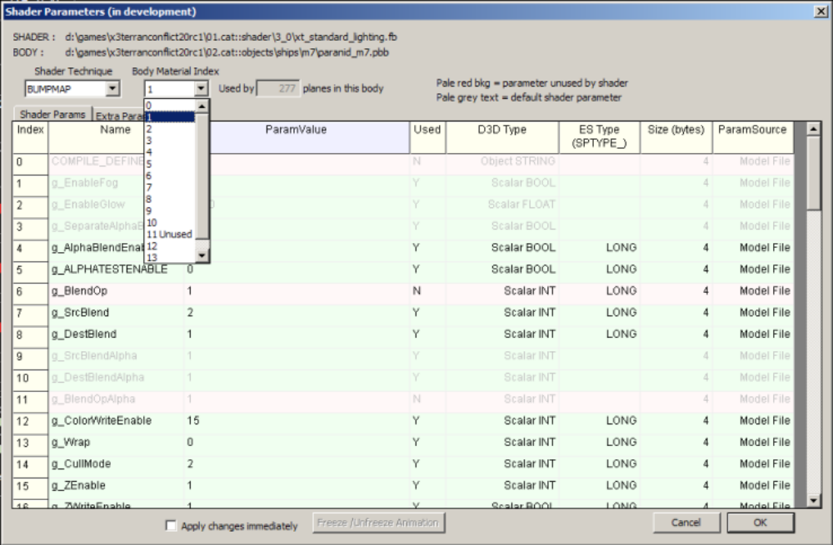

When the model is being rendered with shaders, and a shader item was selected
(eg 01.cat::shader\3_0\argon.fb in row 17 in the 2nd picture up from here)
you can change the shader parameters live, for example the Hue value (just like the Player HQ sprayshop).

This currently only applies to X3 models that are textured with Material6.
Shader rendering quality in this viewer is fairly poor, but it should get better in future versions

Nova pirate raider:
Viewer ‘normal render’ Shader render Hue at 100 rather than 0
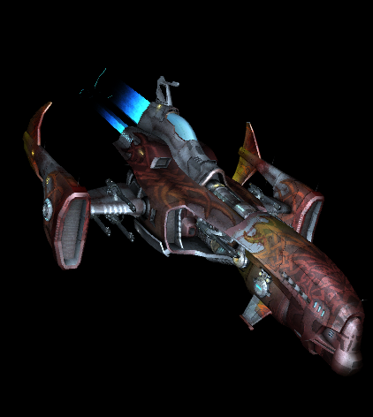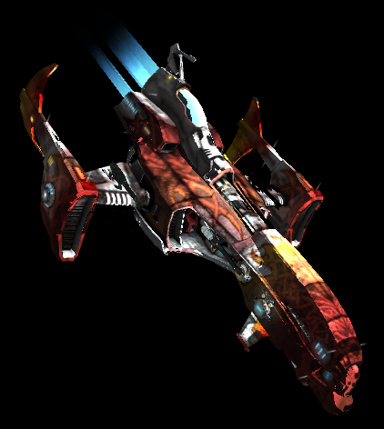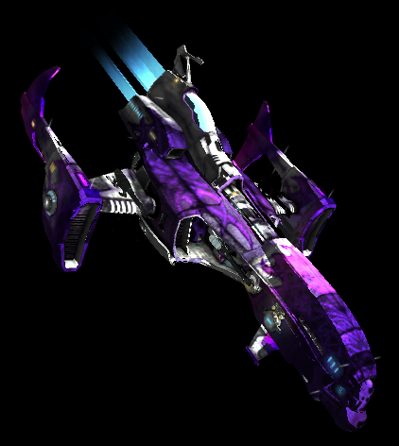

HQ spray-shop simulation

This approximates what happens to ship colours when they are changed in-game with the HQ ‘spray-shop’
functionality.
A dialog for Hue-shift and Saturation is shown:
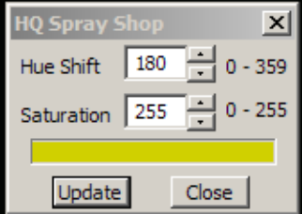

When Update is pressed all relevent textures being currently used will change e.g.:

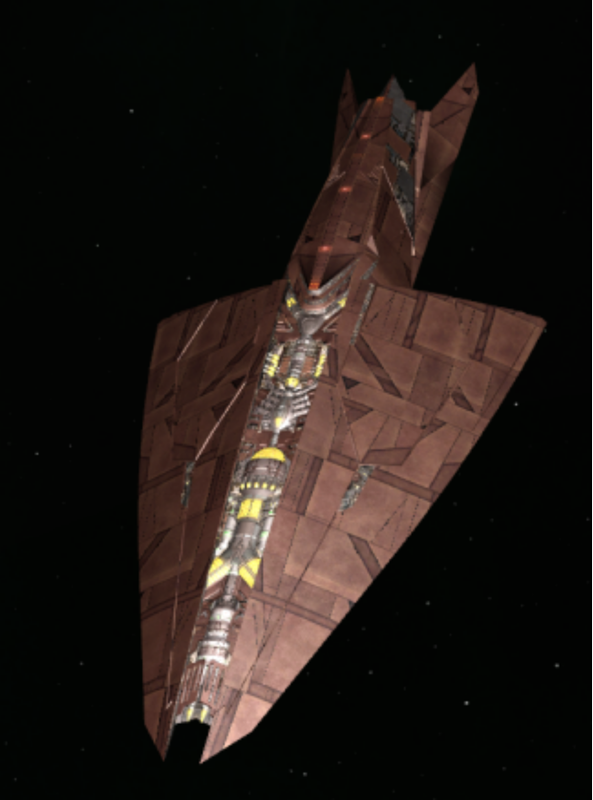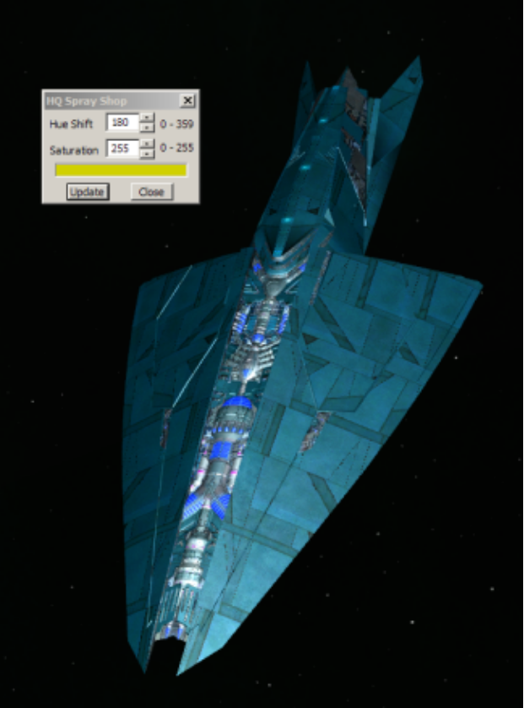

Tile windows horizontal, tile vertical, cascade or maximise windows

These are the same as the standard windows organising functions.

Close all open windows

Close every open window.
If e.g. the Load Ships dialog was showing before, and was hidden by model windows, it will be re-shown now.

Loading files from extracted catalogs

When you activate this, a red indicator rectangle will show at the bottom-right of the screen:
This is really a modding facility.

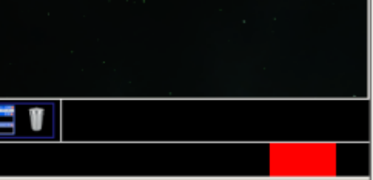

This means that from now on any files loaded will come from extracted files on your disc drive (if present).
These files must have been created with doubleshadow’s X3ModManager (in the X3 Editor program suite)
http://forum2.egosoft.com/viewtopic.php?t=103977

Each cat file MUST have been extracted to a known directory location i.e. in a subdirectory of the X-Game directory chosen i.e.
X2orX3gamedirectory \ EXTRACTEDCATS
On my PC the X3 catalog 01.cat was extracted to ‘D:\GamesX3Fresh2.5bp3107 \ EXTRACTEDCATS\01’
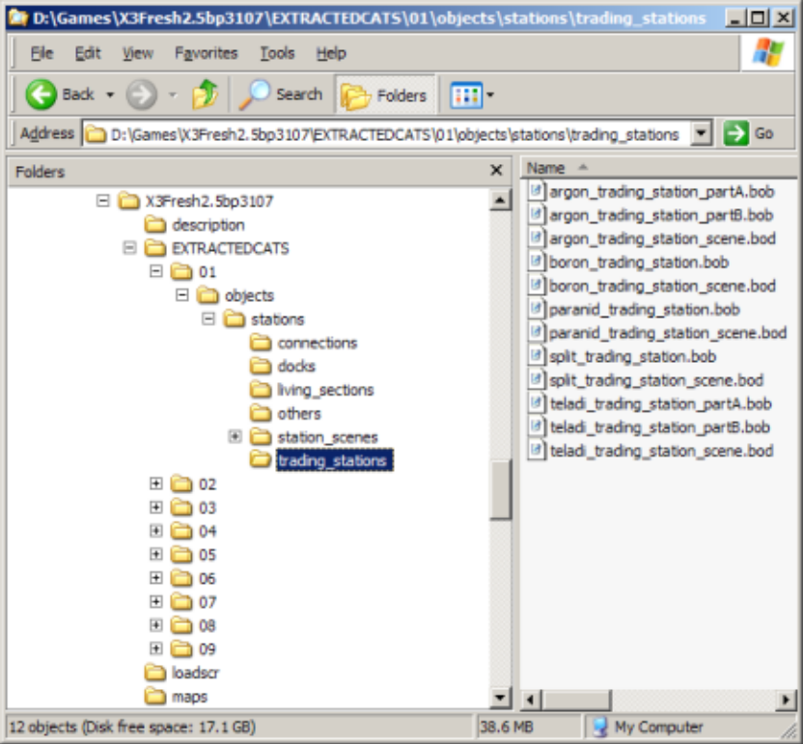
Each cat file must be extracted to a directory that matches (exactly) the name of the cat file.
The object of all this is to be able to edit any extracted file, and compare the result with the original by loading the affected scene/model file twice, once with the turned on, and once with it off.

Also it’s quite interesting just browsing through the files in the extracted catalogs.

If you turn this on, and want to load the ‘initial’ game files (eg TShips.txt or xml files) from extracted files,
then you must close and restart the program.
This mode is ‘sticky’ in that the setting stays as you last had it even when you re-run the program.
If you load TShips etc with this on, then be aware that it is currently very slow to load.

This Viewer can be used as the ‘3D Viewer’ for doubleshadow’s X3Editor / TXT Editor (or the X2 version), when the ‘Settings’ (for the editor’s viewer) are used to point to this program.
NOTE with the current X3 Editor version, your X game directory name cannot have any spaces in it,
otherwise this will not work.
When any of the ‘yellow-cube’ buttons is clicked, the program will launch and load the selected ship/factory etc, if further clicks are made, the models will load into the same instance of the viewer program (new window)

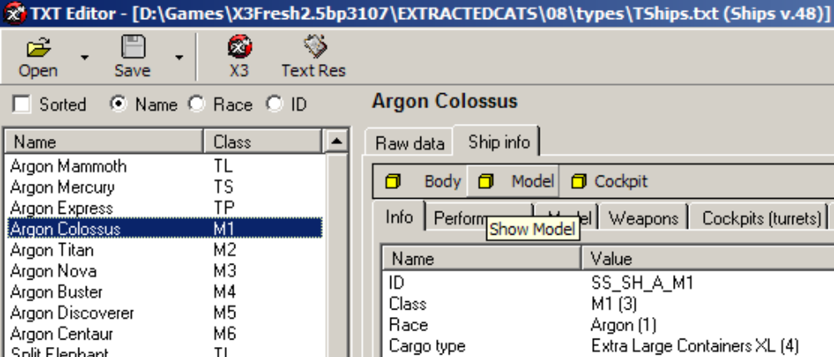

If you have any issues or suggestions or ideas for improvements, then please post them one of the below places:

General issues / suggestions:
http://forum.egosoft.com/viewtopic.php?p=2765992#2765992
This forum post can be checked for Viewer version updates.

Modding issues / suggestions
http://forum2.egosoft.com/viewtopic.php?p=1664751

